Lab Experiment: 4

Title: Playing Melody with Buzzer using Arduino
Course title: IOT Laboratory

Course code: CSE-460
4th Year 1st Semester Examination 2025

Date of Submission: 22/02/2026

Submitted to-

Dr. Md. Ezharul Islam, B.SC.(JU), M.ENGG.(JAPAN), PHD(JAPAN)
Professor
Department of Computer Science and Engineering
Jahangirnagar University

&

Samsun Nahar Khandakar
Assistant Professor
Department of Computer Science and Engineering
Jahangirnagar University
Savar, Dhaka-1342

Class Roll | Exam Roll | Name
383 | 210903 | Abdullah Nazmus-Sakib
379 | 210899 | Shah Sultan
391 | 210911 | Md Khaled Mahmud

Lab–4: Playing Melody with Buzzer using Arduino

📘 1. Title Playing Melody with Buzzer using Arduino

🎯 2. Objective
- To interface a buzzer with an Arduino board
- To generate sound using digital signals
- To play a simple musical melody using programmed notes
- To understand tone generation using frequency and delay

🧰 3. Components Required

Component | Quantity
Arduino Uno (or compatible board) | 1
Buzzer (Active/Passive) | 1
Jumper wires | As required
USB cable | 1
Computer with Arduino IDE | 1

🔌 4. Circuit Connection

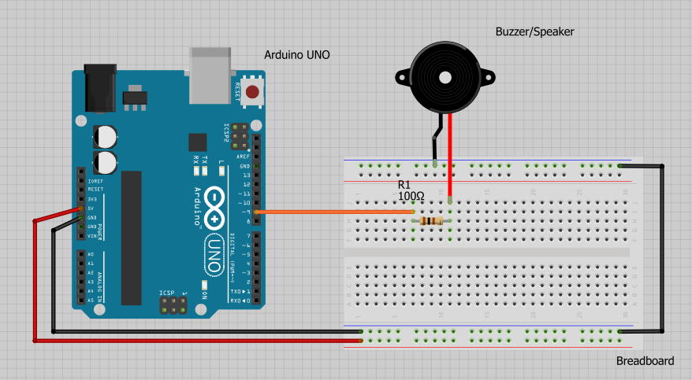

- Buzzer positive (+) terminal → Digital Pin 9 of Arduino
- Buzzer negative (–) terminal → GND of Arduino
This allows Arduino to send HIGH/LOW signals to produce sound waves.

💻 5. Program (Arduino Code)

int buzzerpin = 9;

int length = 15;
char notes[] = "ccggaagffeeddc ";
int beats[] = {1,1,1,1,1,1,2,1,1,1,1,1,1,2,4};
int tempo = 300;

void playTone(int tone, int duration) {
for (long i = 0; i < duration * 1000L; i += tone * 2) {
digitalWrite(buzzerpin, HIGH);
delayMicroseconds(tone);
digitalWrite(buzzerpin, LOW);
delayMicroseconds(tone);
}
}

void playNote(char note, int duration) {
char names[] = {'c','d','e','f','g','a','b','C'};
int tones[] = {1915,1700,1519,1432,1275,1136,1014,956};

for (int i = 0; i < 8; i++) {
if (names[i] == note) {
playTone(tones[i], duration);
}
}
}

void setup() {
pinMode(buzzerpin, OUTPUT);
}

void loop() {
for (int i = 0; i < length; i++) {
if (notes[i] == ' ') {
delay(beats[i] * tempo);
} else {
playNote(notes[i], beats[i] * tempo);
}
delay(tempo / 2);
}
}

⚙️ 6. Working Principle
- Arduino outputs square wave signals from Pin 9
- The buzzer converts electrical pulses into sound
- Different frequencies correspond to different musical notes
- Delay determines note duration (tempo)
- A sequence of notes forms a melody

▶️ 7. Procedure
- Collect all required components
- Connect buzzer to Arduino as shown
- Open Arduino IDE on the computer
- Write or paste the provided code
- Select correct Board and COM port
- Upload the program to Arduino
- Observe the buzzer playing the melody

📊 8. Result

The buzzer successfully produced a musical melody based on programmed notes, demonstrating sound generation using Arduino digital output.

🧠 9. Applications
- Alarm systems
- Doorbells
- Musical toys
- IoT notification devices
- Warning indicators in embedded systems

⚠️ 10. Precautions
- Ensure correct polarity of buzzer
- Avoid short circuits
- Use proper digital pin connection
- Check board and port before uploading

🏁 11. Conclusion

This experiment demonstrated how an Arduino microcontroller can generate sound and play melodies using a buzzer. It provided practical understanding of digital signal output, timing control, and basic sound synthesis — fundamental concepts in IoT and embedded systems.

